

# AIM:

To Create an ARIMA Model for time series forecasting.

# ALGORITHM:

1. ADF Test – Checks if the PM2.5 time series is stationary using statistical significance.
2. Differencing – Transforms non-stationary data to stationary by subtracting consecutive values.
3. ARIMA Model Selection – Chooses ARIMA(p,d,q) model where p = autoregressive lags, d = differencing, q = moving average lags.
4. Model Training – Fits the ARIMA model to historical PM2.5 data using specified parameters.
5. Forecasting – Predicts future PM2.5 values for the next 30 days using the trained model.
6. Visualization – Plots actual vs forecasted PM2.5 levels to visualize model performance.

**Code:**

import pandas as pd

import matplotlib.pyplot as plt

from statsmodels.tsa.arima.model import ARIMA

from pandas.plotting import register_matplotlib_converters

from statsmodels.tsa.stattools import adfuller

import seaborn as sns

register_matplotlib_converters()

# Step 1: Load the dataset

df = pd.read_csv('/content/us_air_pollution_2012_2021_updated.csv', parse_dates=['Date'])

df.set_index('Date', inplace=True)

# Step 2: Handle encoding issues

df.columns = [col.encode('utf-8').decode('utf-8').replace("Â", "") for col in df.columns]

df = df.apply(pd.to_numeric, errors='coerce') # convert all to numeric, force errors to NaN

# Step 3: Drop missing values

df = df.dropna()

# Step 4: Visualize the PM2.5 levels

plt.figure(figsize=(10, 4))

plt.plot(df['PM2.5 (µg/m³)'], label='PM2.5')

plt.title('PM2.5 over time')

plt.legend()

plt.show()

# Step 5: Check stationarity using ADF test

result = adfuller(df['PM2.5 (µg/m³)'])

print('ADF Statistic:', result[0])

print('p-value:', result[1])

# Step 6: Differencing (if p-value > 0.05)

df['PM2.5_diff'] = df['PM2.5 (µg/m³)'].diff().dropna()

# Step 7: Fit ARIMA model (you can tune p,d,q manually or use auto_arima)

model = ARIMA(df['PM2.5 (µg/m³)'], order=(1,1,1)) # Example (p=1, d=1, q=1)

model_fit = model.fit()

# Step 8: Summary

print(model_fit.summary())

# Step 9: Forecast

forecast = model_fit.forecast(steps=30) # Forecasting next 30 time points

# Step 10: Plot forecast

plt.figure(figsize=(10, 4))

plt.plot(df['PM2.5 (µg/m³)'], label='Historical')

plt.plot(pd.date_range(start=df.index[-1], periods=31, freq='D')[1:], forecast, label='Forecast', color='red')

plt.legend()

plt.title('PM2.5 Forecast')

plt.show()

**OUTPUT:**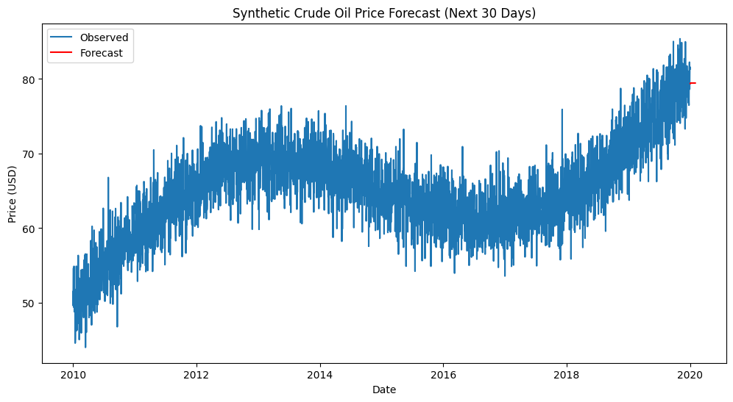

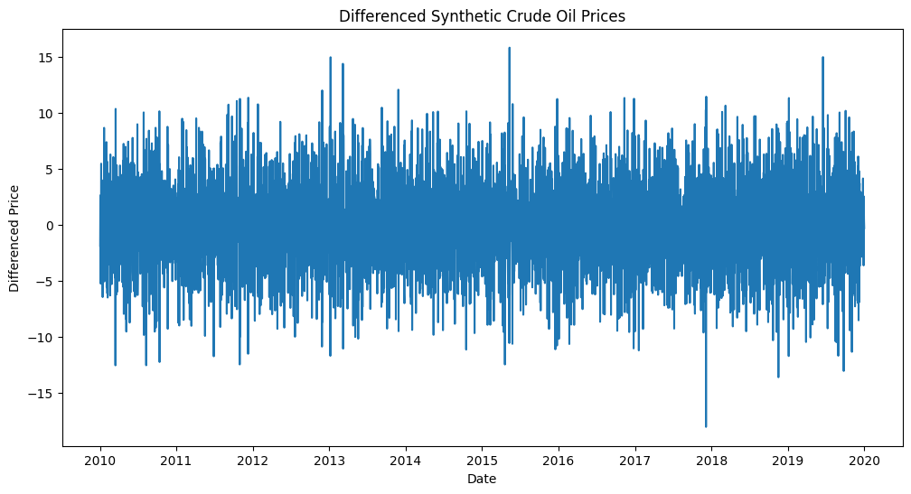

ADF Statistic: -9.886813891901397

p-value: 3.6455466907399357e-17

SARIMAX Results

==============================================================================

Dep. Variable: PM2.5 (µg/m³) No. Observations: 120

Model: ARIMA(1, 1, 1) Log Likelihood -432.639

Date: Sat, 12 Apr 2025 AIC 871.278

Time: 04:33:41 BIC 879.615

Sample: 01-01-2012 HQIC 874.663

- 12-01-2021

Covariance Type: opg

==============================================================================

coef std err z P>|z| [0.025 0.975]

------------------------------------------------------------------------------

ar.L1 0.0723 0.097 0.742 0.458 -0.119 0.263

ma.L1 -0.9665 0.042 -22.821 0.000 -1.050 -0.884

sigma2 82.4100 16.919 4.871 0.000 49.250 115.570

===================================================================================

Ljung-Box (L1) (Q): 0.01 Jarque-Bera (JB): 6.85

Prob(Q): 0.91 Prob(JB): 0.03

Heteroskedasticity (H): 0.71 Skew: 0.06

Prob(H) (two-sided): 0.29 Kurtosis: 1.83

==================================================================================

**RESULT:**

Thus, the program using the time series data implementation has been done successfully.

# 